CPE301 – SPRING 2019

Design Assignment 4A

Student Name: Carlos D Zuniga

Student #: 2000783713

Student Email: zunigc2@unlv.nevada.edu

Primary Github address: https://github.com/cdaniel64/blassen/

Directory: DA4/DA4A

1. **COMPONENTS LIST AND CONNECTION BLOCK DIAGRAM w/ PINS**

List of Components used

Block diagram with pins used in the Atmega328P

Motor Driver

Potentiometer (to regulate motor speed)

Switch

Breadboard

Debugger

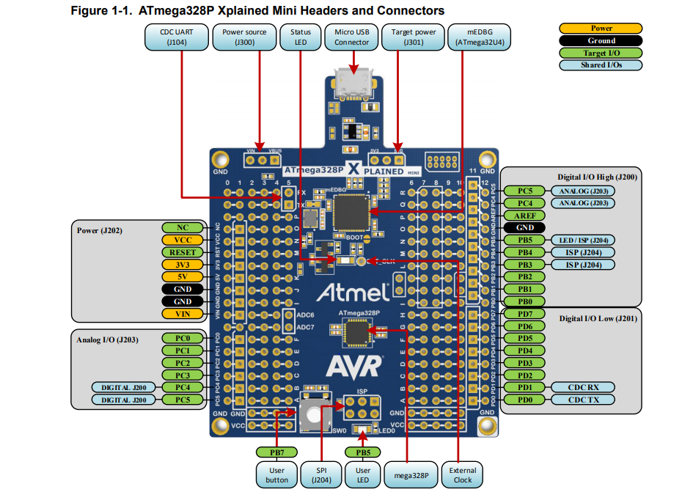

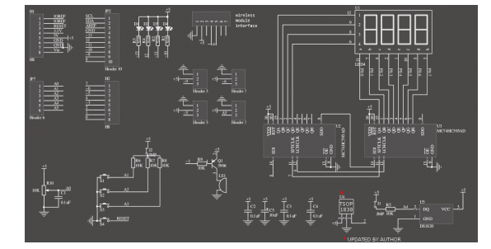

1. **INITIAL/MODIFIED/DEVELOPED CODE OF TASK 1/A**

**ALL CODE IN NOTEPAD SO ITS CLEANER**

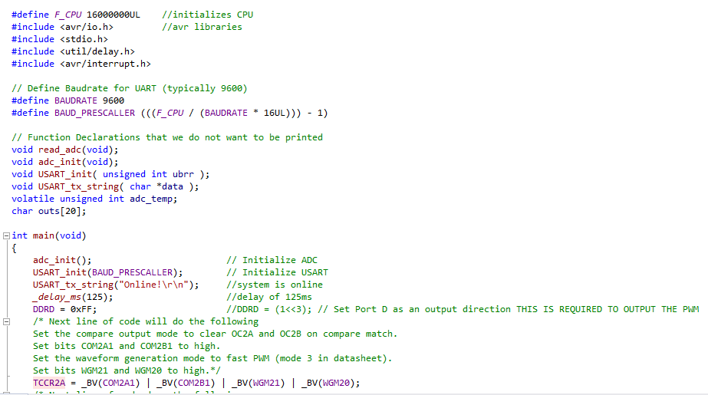

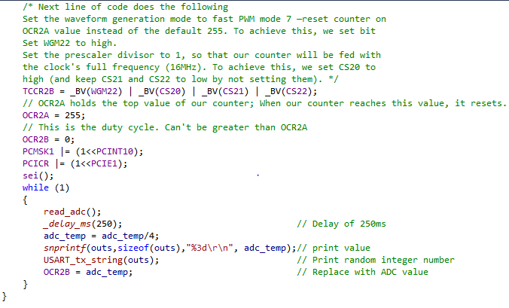

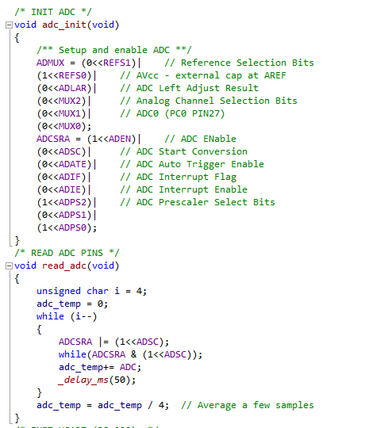

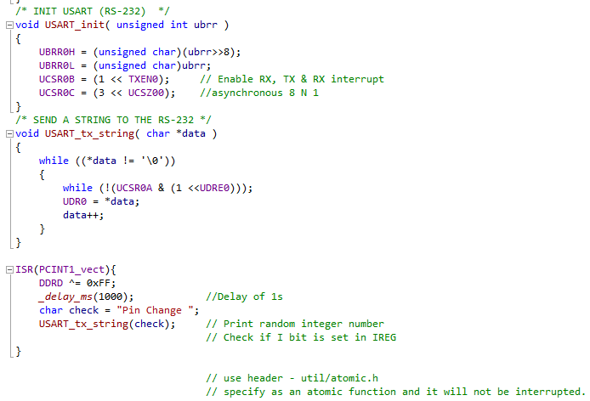

1. **SCHEMATICS**

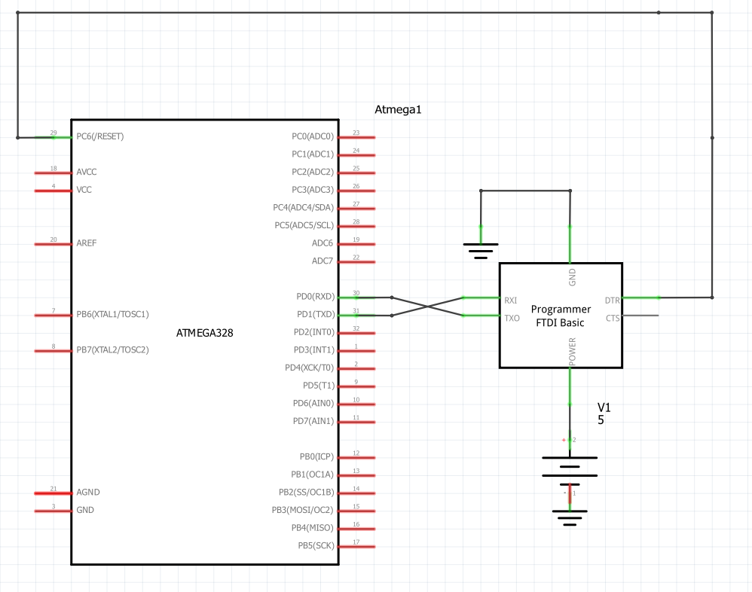

Use fritzing.org

1. **SCREENSHOTS OF EACH TASK OUTPUT (ATMEL STUDIO OUTPUT)**

**Did not display any output on atmel studio**

1. **SCREENSHOT OF EACH DEMO (BOARD SETUP)**

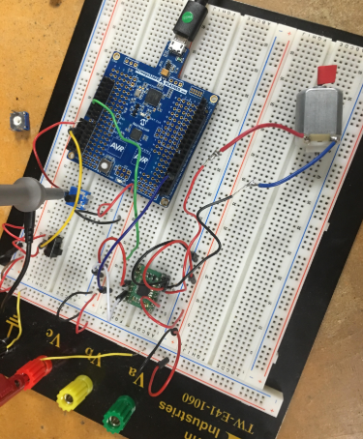

1. **VIDEO LINKS OF EACH DEMO**

[**https://youtu.be/bJ2NdZbQD00**](https://youtu.be/bJ2NdZbQD00)

1. **GITHUB LINK OF THIS DA**

<https://github.com/cdaniel64/blassen>

**Student Academic Misconduct Policy**

<http://studentconduct.unlv.edu/misconduct/policy.html>

“This assignment submission is my own, original work”.